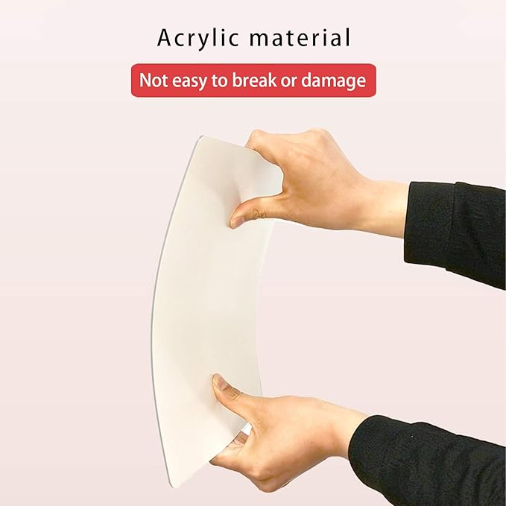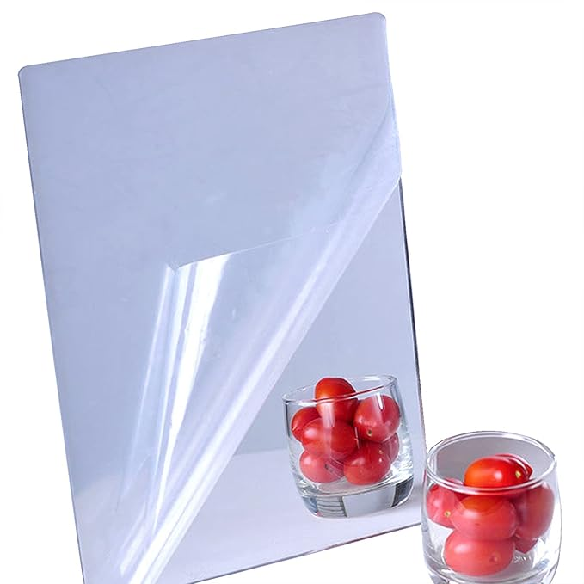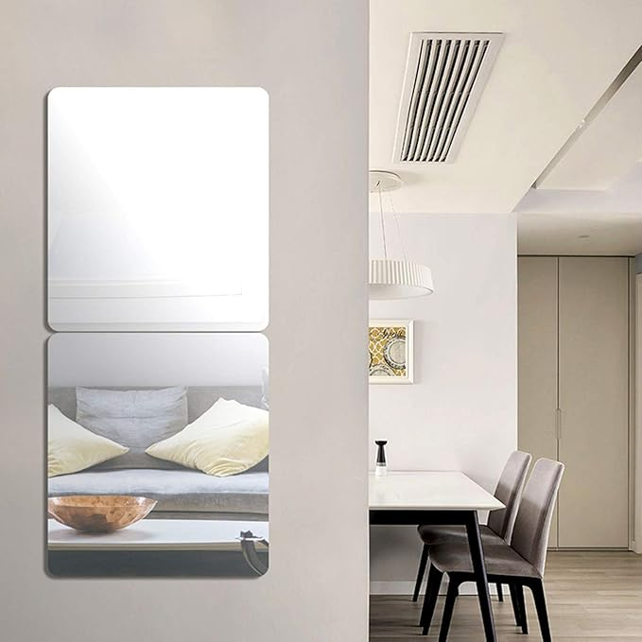

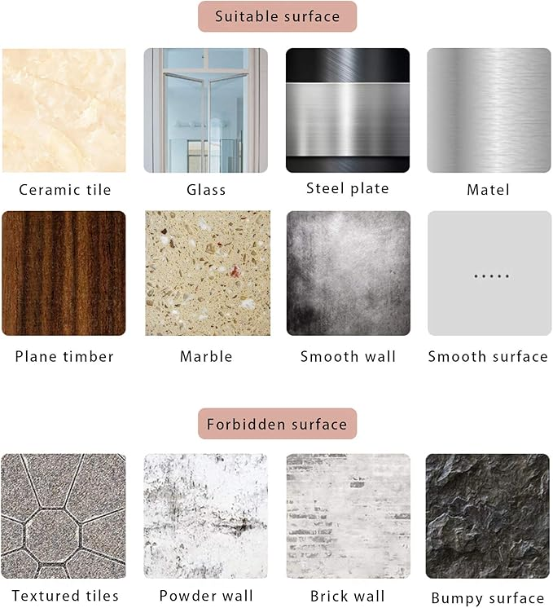

iCAGY Acrylic Self Adhesive Mirror Sheet for Wall, Plastic Non Glass Sticky Kid Safety Mirror Tiles for Wall Rectangle 8x10 inch 1Pcs

**PRODUCT DESCRIPTION:**

|  |  |
| --- | --- |
| **Brand** | iCAGY |
| **Room Type** | Bathroom, Classroom, Playroom |
| **Shape** | Rectangular |
| **Product** | 10"L x 8"W |
| **Frame Material** | Acrylic  **About this item**   * Easy to Install: Self adhesive, peel off the white protective layer on the back * Clear Reflective: Please peel off the protective film of mirror surface after paste on the wall * Not Easy to Break: Made of acrylic material which have flexible texture and shatter resistant; Great for classroom, playroom and kids room * Light Weight: The weight of acrylic mirror is half of glass mirror * Waterproof: Acrylic mirror could be used in bathroom |